CURRICULUM VITAE

NAME: MANZOOR HUSSAIN

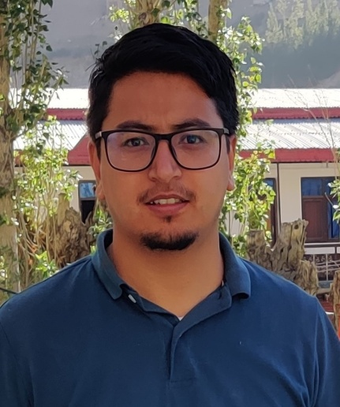
SEX: MALE

MARTIAL STATUS: MARRIED

ADRESS: DEPARTMENT OF CHEMISTRY,
GOVT. DEGREE COLLEGE DRASS, LADAKH
J & K, INDIA, PIN CODE 194103
CONTACT NO- 8082029728(Mobile)
6005445417 (Mobile)
01985-233374(office)
EMAIL- manzoor356@gmail.com

CURRENT DESIGNATION: ASSISTANT PROFESSOR

QUALIFICATION: MSc. CHEMISTRY FROM, INDIAN INSTITUTE OF TECHNOLOGY (IIT) DELHI, HAUZ KHAS NEW DELHI
PIN CODE-190006

1. Qualified National eligibility test (NET) in Chemical Sciences with all India rank of 70 for Lectureship held 0n 23rd December -2012. NET is conducted at national level jointly by University Grants Commission (UGC) and Centre for Scientific and Industrial Research (CSIR), Govt. of India, New Delhi.

2. Qualified Graduate Aptitude Test in Engineering (GATE) in Chemistry in the year 2012 and 2013.

DATE OF JOINING: 16st of May 2017

TEACHING EXPERIENCE: 5 years

EDUCATIONAL DETAILS
DEGREE | INSTITUTE/UNIVERSITY | MARKS | GRADUATION | DIVISION
M.Sc. (Chemistry) | Indian Institute Of Technology, Delhi | 70% | 2012 | 1st
B.Sc. (Honors) Chemistry | Hindu College, Delhi University | 60.14% | 2010 | 1st

EXAMINATION | INSTITUTE/ BOARD | SCHOOL | MARKS OBTAINED | DIVISION
Secondary Exam | JKBOSE | SP Hr Sec School Jammu | 73% | 1st
Senior Secondary Exam | JKBOSE | SP Hr Sec School Jammu | 66% | 1st

WORKSHOP, SEMINAR, TRAINING COURSE ORIENTATION / REFRESHER COURSE ATTENDED:
- Attended two day teacher training Workshop as the part of Royal Society of Chemistry Yusuf Inspirational Chemistry Programme from 17th August t0 18th August 2017 held at DIET Kargil Ladakh Jammu and Kashmir.
- Participated in three week “orientation course” from 26th April. 2017 at Institute of Advanced Studies in Education Government College of Education M.A. Road, Srinagar Jammu and Kashmir.
- Participated in the three days National Conference on Recent Advances and Innovations in Artificial Intelligence , Machine Learning and Deep Learning held at Satellite Campus Kargil (Ladakh), University of Kashmir from 3th to 5th October 2019.
- Participated in the one week Science Leadership Workshop organized by the Central University of Punjab, Bathinda, India from 22 June to 28 June 2020.
- Participated in the Faculty Development Programme on Design, Develop and Deliver Online Courses organized by National Institute of Educational Planning and Administration (NIEPA) from June 14-18, 2021.
- Participated in online two-week Faculty Development Programme (equivalent to Refresher Course) on “Chemistry - The Catalyst for Change” from 14 July – 28 July, 2021 and obtained Grade A+.
- Participated in the International Web Conference on “Emerging Fields in Chemistry: Advances and Applications” organized by Department of Chemistry, Government Kamla Devi Rathi Girls Postgraduate College, Rajnandgaon from 10-11 August, 2021.
- Participated in one week Faculty Development Programme organized by University of Ladakh in collaboration with Tata Institute of Social Science, Mumbai from 2nd to 8th September 2021.
- Participated in online one-week Faculty Development Programme on “Chemical Sciences-Recent trends and applications” organized by Department of Chemistry, University Institute of Sciences, Chandigarh University from 6-10 June, 2022.

Publication: - 1. Synthesis of Core–Shell Quantum Dots and their potential application Published in Advanced Nanomaterials and Nanotechnology Springer Proceedings in Physics 143, DOI: 10.1007/978-3-642-34216-5_8, ISSN 3642342159 (Online)

